**软件需求与建模第二次实验报告**

**田晓枫 计算机学院 2022302111298 17791172056**

一、未修改的方案

1.1用例图：

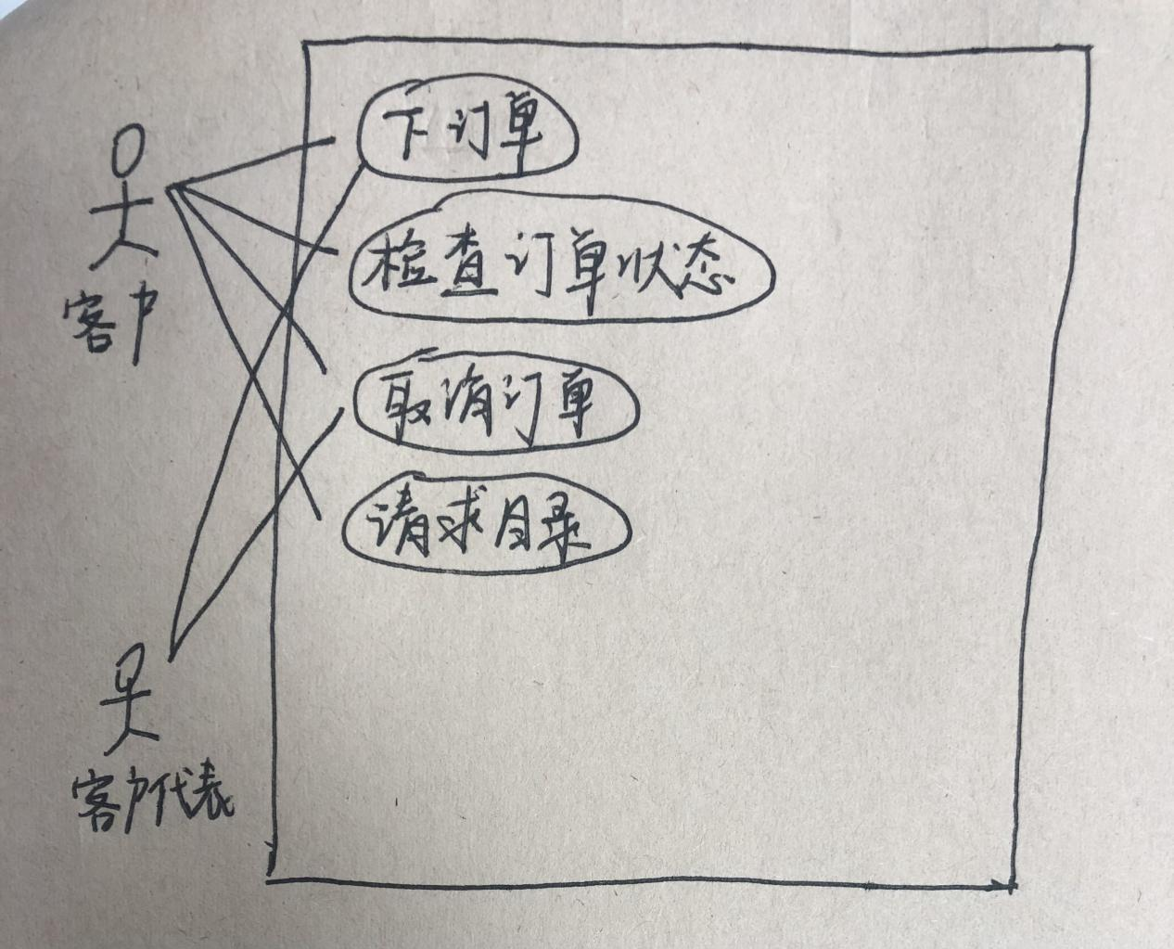

1.2类图：

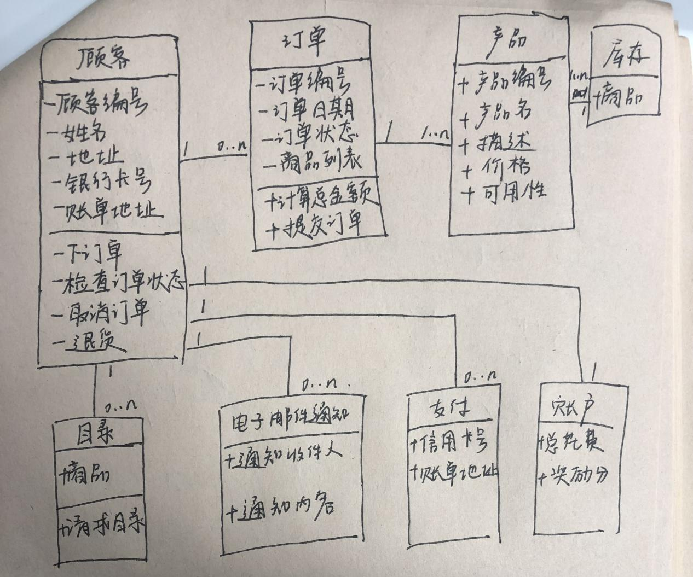

1.3顺序图：

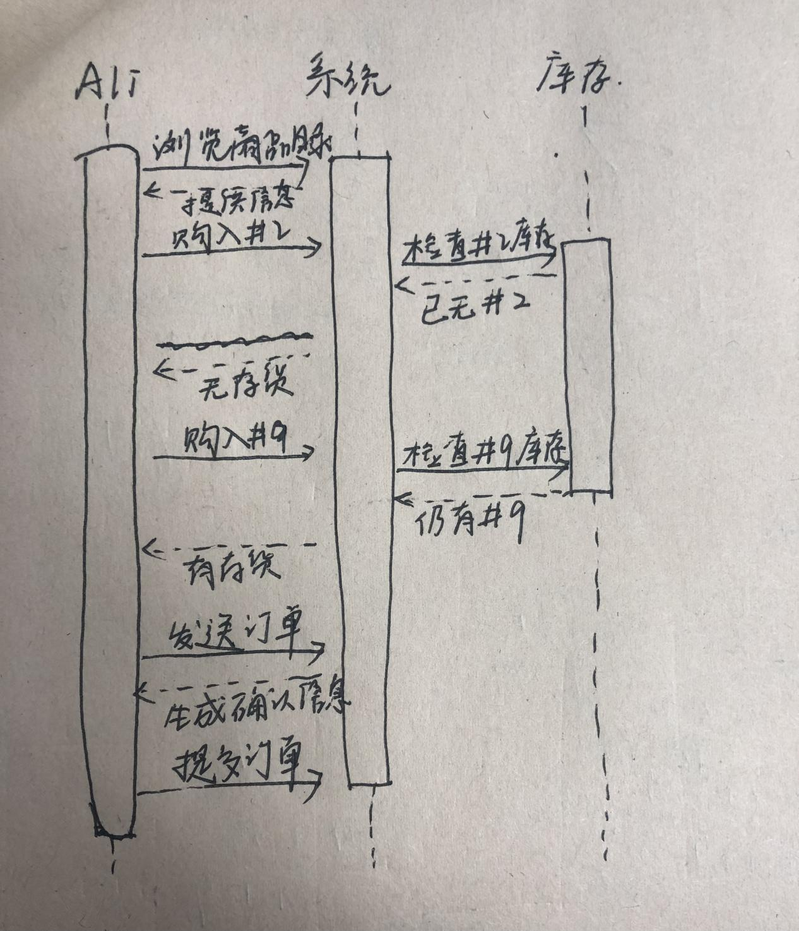

二、修改后的方案

2.1用例图：

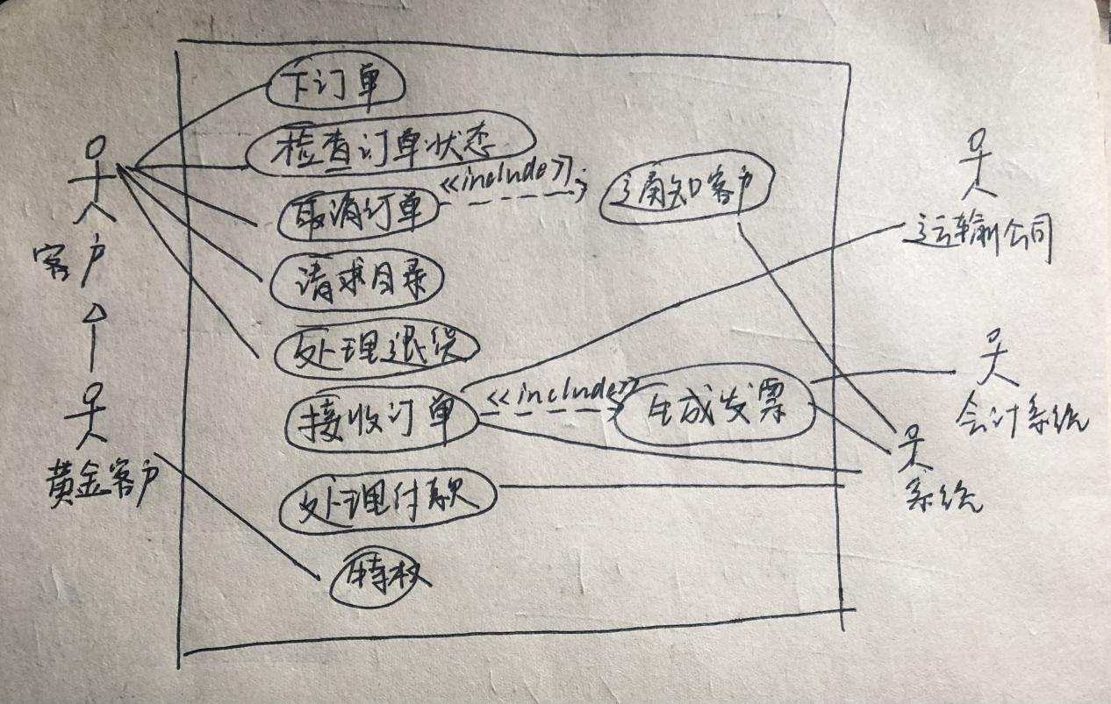

2.2类图：

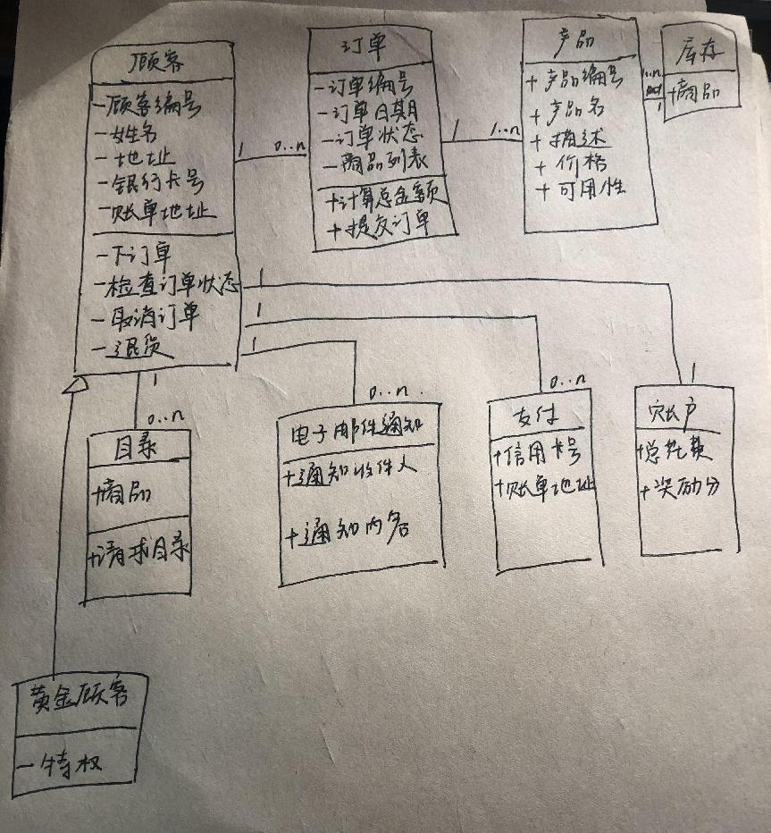

2.3顺序图：

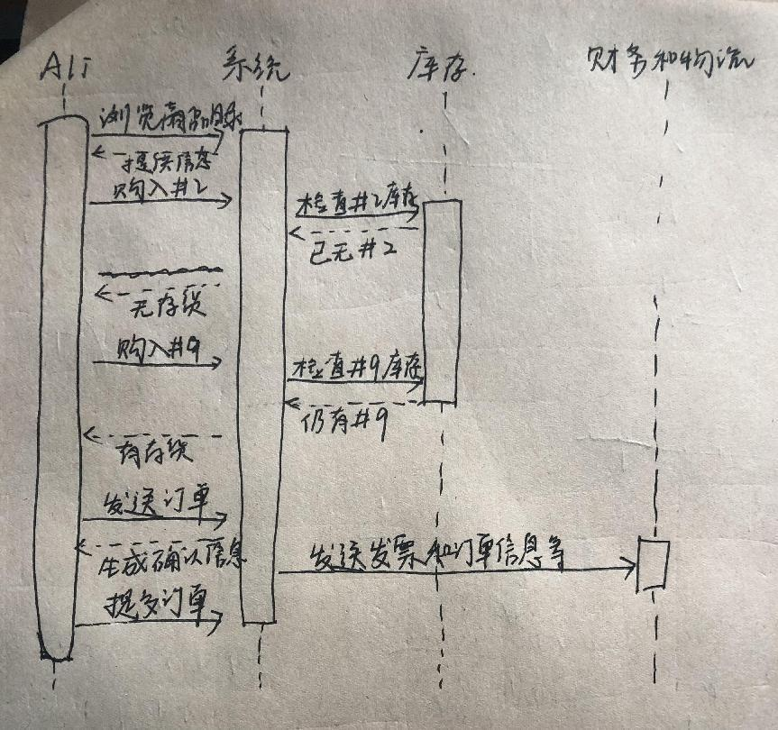

三、方案对比

3.1用例图：

1.新增用例“处理退货”、“接受订单”、“处理付款”、“特权”、“生成发票”和“通知客户”。

2.新增参与者：黄金客户、运输公司、系统和会计系统

3.新增部分扩展关系，例如“取消订单”与“通知客户”之间存在扩展关系。

3.2类图：

1.新增黄金顾客类泛化顾客

2.新增库存类

3.3顺序图：

1.新增财务与物流系统

2.新增发送订单后发送发票和订单信息

四、与Chatgpt的聊天记录

4.1用例图：

OOA using UML Consider the following problem description: A mail-order company wants to automate its order processing. The initial version of the order processing system should be accessible to customers via the web. Customers can also call the company by phone and interact with the system via a customer representative. It is highly likely that the company will enhance this system in upcoming years with new features. The system allows customers to place orders, check the status of their orders, cancel an existing order and request a catalog. Customers may also return a product but this is only possible through the phone, not available on the web. When placing an order, the customer identifies himself by means of customer number (only for existing registered customers) or by means of his name and address. He then selects a number of products by giving the product number or by selecting products from the online catalogue. For each product, information such as price, a description and a picture (only on demand as they are usually high-resolution images of large size) are presented to the customer. Also the availability of the product is obtained from the inventory. The customer indicates whether he wants to buy the product and in what quantity. When all desired products have been selected, the customer provides a shipping address and a credit card number and a billing address (if different from the shipping address). Then an overview of the ordered products and the total cost are presented. If the customer approves, the order is submitted. Credit card number, billing address and a specification of the cost of the order are used on the invoice, which is forwarded to the accounting system (an existing software module). Orders are forwarded to the shipping company, where they are filled and shipped. Customers who spent over a certain amount within the past year are promoted to be gold customers. Gold customers have additional rights such as being able to return products in an extended time period as well as earning more bonus points with each purchase. In addition, in cases where a product is on back order, gold customers have the option to sign up for an email notification for when the particular product becomes available. (1). Identify actors and use cases for the system described above and show them on a UML Use Case Diagram. (2) Perform a quick application domain analysis to come up with an object model for the above system. Express your findings with a UML Class Diagram, making sure to identify any critical operations of classes. (3) draw a UML Sequence Diagram for this particular scenario. You may use any software/solution domain objects if needed as well. Consider the following use case scenario(for use case “place order”): Ali is an existing customer of the order processing company described earlier, registered with their web site. Also assume that having browsed the printed catalogue he has, he already identified the two items (including their prices) he likes to buy from the company’s website using their product numbers (i.e. #2 and #9). First he tries to buy one of product #2, but it is listed as unavailable in the inventory. Then, he adds two quantities of product #9, which turns out to be available, to his basket. He is then asked to confirm his registered shipping and billing addresses and credit card information from the customer database. He completes the order by clicking the Submit button. You may ignore processing of customer authentication. 1.识别上面描述的系统的参与者和用例，以及参与者和用例之间的关系，并在UML用例图上显示它们。用中文回答我。

参与者包括客户（通过网站）和客户代表（通过电话）。用例包括下订单、检查订单状态、取消订单和请求目录。客户通过网站访问的用例有：下订单、检查订单状态、取消订单、请求目录。通过电话的客户访问的用例有：下订单、取消订单、请求目录。客户代表的用例有：下订单、取消订单。

客户和客户代表是否为同一个参与者

不完全相同。客户代表是公司员工，代表客户与系统交互。客户则是公司的消费者。虽然他们都与系统交互，但他们的角色和权限可能不同。

可以清晰地分别罗列出参与者、用例和参与者与用例之间的关系吗

参与者：

客户（通过网站）

客户代表（通过电话）

用例：

下订单

检查订单状态

取消订单

请求目录

参与者与用例之间的关系：

客户与下订单、检查订单状态、取消订单、请求目录有关联

客户代表与下订单、取消订单有关联

我觉得客户和客户代表为同一参与者，通过网站和通过电话两种区别应当在用例中展现开。另外，黄金客户、系统（处理订单的系统）、运输公司和会计系统也应当是参与者。请根据我的意见进行修改，然后告诉我参与者、用例和参与者与用例之间的关系。

参与者：

客户（通过网站或电话）

系统（处理订单的系统）

运输公司

会计系统

用例：

下订单

检查订单状态

取消订单

请求目录

处理退货

接收订单

生成发票

处理付款

通知客户

参与者与用例之间的关系：

客户与下订单、检查订单状态、取消订单、请求目录、处理退货有关联

系统与接收订单、生成发票、处理付款有关联

运输公司与接收订单有关联

会计系统与生成发票有关联

系统与通知客户有关联

用例之间的关系是什么？

用例之间的关系通常可以通过包含（包含关系）、扩展（扩展关系）、泛化（泛化关系）等方式来表示。

在这个场景下，用例之间的关系可能包括：

下订单用例可能包含处理付款、生成发票、接收订单等用例，因为下订单过程中需要完成这些子任务。

取消订单用例可能扩展自下订单用例，因为取消订单是在下订单的基础上进行的。

处理退货用例可能与下订单用例有关联，因为退货可能需要先了解订单的状态。

接收订单用例可能与生成发票用例有关联，因为收到订单后可能需要生成相应的发票。

通知客户用例可能与取消订单用例有关联，因为订单取消后可能需要通知客户。

这些关系可以在用例图中以箭头表示，表明了用例之间的依赖关系或扩展关系。

4.2类图：

OOA using UML Consider the following problem description: A mail-order company wants to automate its order processing. The initial version of the order processing system should be accessible to customers via the web. Customers can also call the company by phone and interact with the system via a customer representative. It is highly likely that the company will enhance this system in upcoming years with new features. The system allows customers to place orders, check the status of their orders, cancel an existing order and request a catalog. Customers may also return a product but this is only possible through the phone, not available on the web. When placing an order, the customer identifies himself by means of customer number (only for existing registered customers) or by means of his name and address. He then selects a number of products by giving the product number or by selecting products from the online catalogue. For each product, information such as price, a description and a picture (only on demand as they are usually high-resolution images of large size) are presented to the customer. Also the availability of the product is obtained from the inventory. The customer indicates whether he wants to buy the product and in what quantity. When all desired products have been selected, the customer provides a shipping address and a credit card number and a billing address (if different from the shipping address). Then an overview of the ordered products and the total cost are presented. If the customer approves, the order is submitted. Credit card number, billing address and a specification of the cost of the order are used on the invoice, which is forwarded to the accounting system (an existing software module). Orders are forwarded to the shipping company, where they are filled and shipped. Customers who spent over a certain amount within the past year are promoted to be gold customers. Gold customers have additional rights such as being able to return products in an extended time period as well as earning more bonus points with each purchase. In addition, in cases where a product is on back order, gold customers have the option to sign up for an email notification for when the particular product becomes available. (1). Identify actors and use cases for the system described above and show them on a UML Use Case Diagram. (2) Perform a quick application domain analysis to come up with an object model for the above system. Express your findings with a UML Class Diagram, making sure to identify any critical operations of classes. (3) draw a UML Sequence Diagram for this particular scenario. You may use any software/solution domain objects if needed as well. Consider the following use case scenario(for use case “place order”): Ali is an existing customer of the order processing company described earlier, registered with their web site. Also assume that having browsed the printed catalogue he has, he already identified the two items (including their prices) he likes to buy from the company’s website using their product numbers (i.e. #2 and #9). First he tries to buy one of product #2, but it is listed as unavailable in the inventory. Then, he adds two quantities of product #9, which turns out to be available, to his basket. He is then asked to confirm his registered shipping and billing addresses and credit card information from the customer database. He completes the order by clicking the Submit button. You may ignore processing of customer authentication. 2.请根据以上内容构建UML类图，要求表明清楚有哪些类，每个类的属性和方法是什么，类与类之间的联系是什么，请用中文回答我。

首先，我们来创建一个 UML 用例图来识别参与者和用例：

参与者：

Customer (顾客)

Customer Representative (客户代表)

用例：

Place Order (下订单)

Check Order Status (查看订单状态)

Cancel Order (取消订单)

Request Catalog (请求目录)

Return Product (退货)

现在，让我们来构建一个 UML 类图来表示对象模型，其中包含以下类和关键操作：

类：

Customer (顾客)

属性：customerNumber, name, address, creditCardNumber, billingAddress, shippingAddress

方法：placeOrder(), checkOrderStatus(), cancelOrder(), returnProduct()

Order (订单)

属性：orderNumber, orderDate, orderStatus, orderTotal

方法：calculateOrderTotal(), addItem(), removeItem(), submitOrder()

Product (产品)

属性：productNumber, productName, description, price, availability

Catalog (目录)

属性：catalogItems

方法：requestCatalog()

Payment (支付)

属性：creditCardNumber, billingAddress

Account (账户)

属性：totalAmountSpent, bonusPoints

Inventory (库存)

属性：products

EmailNotification (电子邮件通知)

属性：notificationRecipient, notificationMessage

类之间的关系：

Customer 与 Order 之间是关联关系，一个顾客可以拥有多个订单。

Customer 与 Catalog 之间是关联关系，一个顾客可以请求多个目录。

Customer 与 Payment 之间是关联关系，一个顾客可以进行多次支付。

Customer 与 Account 之间是关联关系，一个顾客有一个账户。

Order 与 Product 之间是关联关系，一个订单可以包含多个产品。

Product 与 Inventory 之间是关联关系，一个产品可以存在于库存中。

Customer 与 EmailNotification 之间是关联关系，一个顾客可以接收多个电子邮件通知。

接下来，我们可以创建一个 UML 时序图来描述 "place order" 这个用例的情景。

我觉得还需要一个黄金客户类

好的，让我们将黄金客户类添加到类图中：

类：

GoldCustomer (黄金客户)

属性：customerNumber, name, address, creditCardNumber, billingAddress, shippingAddress, totalAmountSpent, bonusPoints

方法：placeOrder(), checkOrderStatus(), cancelOrder(), returnProduct(), signUpForEmailNotification()

黄金客户与顾客类之间是继承关系，因为黄金客户是顾客的特殊情况。

现在，类图包含了黄金客户类以及与其他类之间的关系。接下来，我们可以继续创建用于 "place order" 场景的 UML 时序图。

类与类之间有除了关联关系外的其他关系吗？

除了关联关系外，类与类之间可能还有其他关系，如依赖关系、聚合关系和组合关系。

依赖关系：当一个类的实现依赖于另一个类的实现时，它们之间存在依赖关系。这种关系通常表示一个类的方法使用了另一个类作为参数或者局部变量。

聚合关系：聚合关系表示整体与部分之间的关系，但是部分可以独立存在于整体之外。在 UML 类图中，聚合关系通常用空心菱形箭头表示。

组合关系：组合关系也表示整体与部分之间的关系，但是部分不能独立存在于整体之外。在 UML 类图中，组合关系通常用实心菱形箭头表示。

在给定的问题描述中，我们可以将以下关系添加到类图中：

依赖关系：例如，订单可能依赖于产品类来计算订单总额。

聚合关系：例如，一个订单可以包含多个产品，但产品可以独立存在。

组合关系：例如，一个订单可能包含具体的支付信息，且支付信息应该随订单的创建而创建，不应该在订单之外存在。

这些关系有助于更好地描述类之间的交互和依赖关系。

4.3顺序图：

OOA using UML

Consider the following problem description: A mail-order company wants to automate its order processing. The initial version of the order processing system should be accessible to customers via the web. Customers can also call the company by phone and interact with the system via a customer representative. It is highly likely that the company will enhance this system in upcoming years with new features. The system allows customers to place orders, check the status of their orders, cancel an existing order and request a catalog. Customers may also return a product but this is only possible through the phone, not available on the web. When placing an order, the customer identifies himself by means of customer number (only for existing registered customers) or by means of his name and address. He then selects a number of products by giving the product number or by selecting products from the online catalogue. For each product, information such as price, a description and a picture (only on demand as they are usually high-resolution images of large size) are presented to the customer. Also the availability of the product is obtained from the inventory. The customer indicates whether he wants to buy the product and in what quantity. When all desired products have been selected, the customer provides a shipping address and a credit card number and a billing address (if different from the shipping address). Then an overview of the ordered products and the total cost are presented. If the customer approves, the order is submitted. Credit card number, billing address and a specification of the cost of the order are used on the invoice, which is forwarded to the accounting system (an existing software module). Orders are forwarded to the shipping company, where they are filled and shipped. Customers who spent over a certain amount within the past year are promoted to be gold customers. Gold customers have additional rights such as being able to return products in an extended time period as well as earning more bonus points with each purchase. In addition, in cases where a product is on back order, gold customers have the option to sign up for an email notification for when the particular product becomes available.

(1). Identify actors and use cases for the system described above and show them on a UML Use Case Diagram.

(2) Perform a quick application domain analysis to come up with an object model for the above system. Express your findings with a UML Class Diagram, making sure to identify any critical operations of classes.

(3) draw a UML Sequence Diagram for this particular scenario. You may use any software/solution domain objects if needed as well.

Consider the following use case scenario(for use case “place order”):

Ali is an existing customer of the order processing company described earlier, registered with their web site. Also assume that having browsed the printed catalogue he has, he already identified the two items (including their prices) he likes to buy from the company’s website using their product numbers (i.e. #2 and #9). First he tries to buy one of product #2, but it is listed as unavailable in the inventory. Then, he adds two quantities of product #9, which turns out to be available, to his basket. He is then asked to confirm his registered shipping and billing addresses and credit card information from the customer database. He completes the order by clicking the Submit button. You may ignore processing of customer authentication.

构建一个UML序列图，请用中文回答我。

好的，让我们开始绘制UML顺序图来描述Ali执行“place order”用例的具体步骤。

首先，Ali登录到公司的网站，并选择“place order”选项。

然后，系统显示产品目录给Ali。Ali浏览目录并选择要购买的产品。

接下来，Ali尝试购买产品 #2，但系统显示该产品无库存。

然后，Ali成功添加两个产品 #9 到购物篮中。

系统提示Ali确认他的注册运送和账单地址以及信用卡信息。

最后，Ali点击“Submit”按钮完成订单。

以上就是整个“place order”用例的具体步骤。

我觉得还需要添加财务和物流参与顺序图

好的，我们可以添加财务和物流参与的步骤到顺序图中。

首先，当Ali点击“Submit”按钮提交订单时，订单信息将被发送到财务系统以生成发票。

财务系统生成发票后，将订单信息和发票发送给物流公司。

物流公司收到订单信息后，开始处理订单并进行发货。

这些步骤描述了财务和物流参与的过程。整个顺序图现在包含了从Ali提交订单到订单处理和发货的完整过程。